Agenda

- INTRODUCTION
- EN PAYMENT RULES AND APPLICATION
  - Phase 1 / Phase 2 Milestones – Part I
    - Benefits
    - Attainment Month
    - Payment Request Form (PRF)
- Questions and Answers
Aaron Aybar hosted the June 2013 call and introduced the following presenters:
- Debbra Tennessee, Ticket Operations Manager, Operations Support Manager (OSM)
- Dr. Cara Caplan, Deputy Director, Social Security Office of Ticket Operations and Provider Support Services
- Aaron Aybar, EN Payments Help Desk Supervisor; OSM
- Charles Powell, EN Payments Help Desk Technical Assistant, OSM

The June All EN Payments Call is Part 1 of a 3 part series of calls to be held in June, July, and August 2013, devoted to the presentation and analysis of case studies that demonstrate how the OSM EN Payments Department staff applies the Ticket to Work Regulations, as well as the operational guidelines provided by the Office of Ticket Operations and Provider Support Services (OTOPS) at the Social Security Administration’s Office of Employment Support Programs (OESP).

EN Payment Rules and Application (Aaron Aybar)
Phase 1 / Phase 2 Milestones - Benefits.
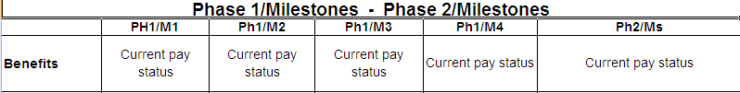
- Rule: Benefits must be in current pay status. If beneficiary is receiving both Social Security Disability Insurance (SSDI)/ Supplemental Security Income (SSI) benefits (Concurrent), at least one of the benefits must be in current pay status.

Phase 1 / Phase 2 Milestones – Attainment month.
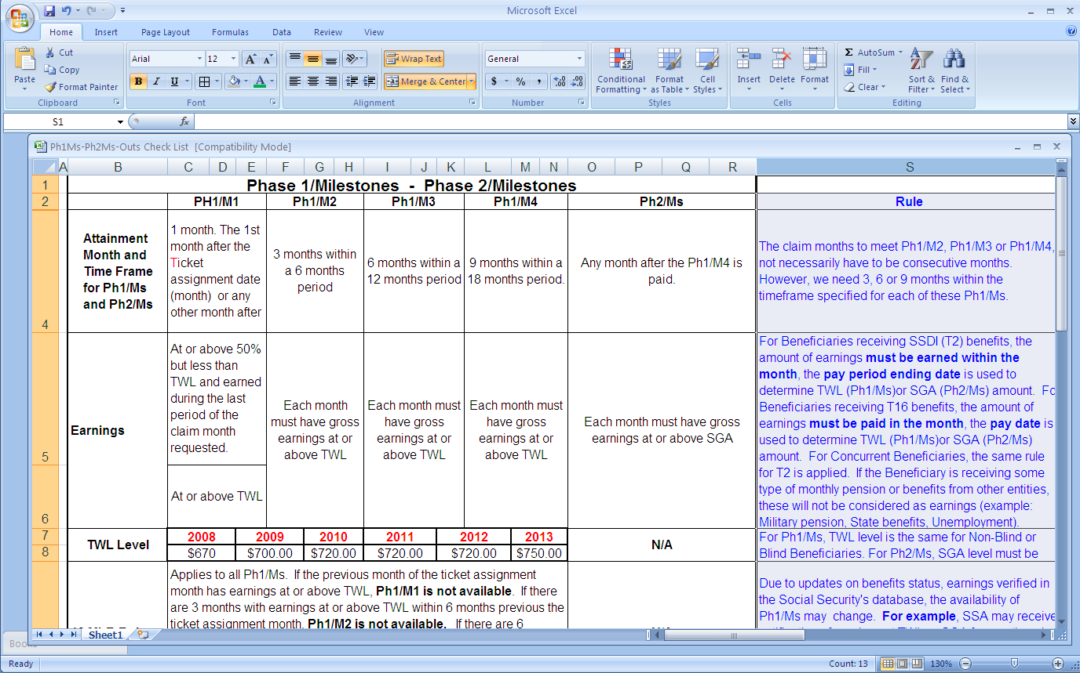
- Rule: The claim months needed to meet Phase 1 Milestone 2, Phase 1 Milestone 3 or Phase 1 Milestone 4, do not necessarily have to be consecutive months. However, it is required that 3, 6, or 9 months of earnings be accrued within the particular timeframe specified for each of these Phase 1 Milestones before the EN qualifies to receive payment.

Phase 1 / Phase 2 Milestones – Payment Request Form (PRF)
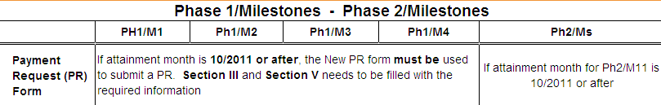
- Rule: Select the correct option on Section III. Complete Section V with the specific date (or time frame) and the services provided to the Beneficiary since Ticket assignment or the last payment received for Phase 1 Milestones 1, 2 and 3. Section III and Section V do not apply for Phase 1 Milestone 4 or Phase 2 Milestones.

QUESTIONS & ANSWERS
Secure Provider Portal (EN Portal)
Is there a glitch on the EN Portal which does not reflect that a client has used their ticket for VR services?
OSM is working to add VR closure information for the secure provider portal.

Social Security Local Field Offices
I have issues with the local field offices not giving receipts and giving misinformation to beneficiaries. Do I have any recourse?
Several ENs commented that they have scheduled appointments with SSA field office staff to talk about the Ticket to Work Program, so that SSA staff understand the effect of what they say when it comes to encouraging beneficiaries to work and use the program.

