Announcements
- Transition of Call Hosting Duties
  - Transition Call hosting duties from Janet Cousins to Shawn Walcott, EN Payments Manager.
- New Pay Rates for 2016
- New TWL & SGA for 2016:
  - TWL: $810
  - SGA non-blind: $1,130
  - SGA blind: $1,820
E-PAY status
- Processing of 2nd E-PAY file began on 11/2/15.
- Total claims paid from that file: Over 25,000
- Claims were processed by SSN instead of DUNS
- Next file expected late January/early February

- REMINDER #1: You may submit your payment request through the ticket portal instead of waiting for the E-PAY process to run.
- REMINDER #2: Please ensure that your EN Contact for Payments information is current. We reference it for payment outreach messages and confirmation of possible Split Payments.

Ticket Portal Tips & Tricks (Review the presentation posted online or listen to the audio recording of the meeting for more details.)

- Payment Status options
There are two options to view payment status from the Payments section of the Main Menu.
- “View payments already made to me”
  - Includes all payments that are closed.
  - Includes both paid and denied requests.
- “View all pending payments for me”
  - Includes all payments that are still open.
Pending payments will include all payments that have not been sent to the Treasury yet
- Must complete ALL fields marked with an asterisk.
- There are three options for Evidence Type:
- Must create separate records for each piece of evidence you have.
- No need to enter earnings that overlap multiple months more than once.
- You may enter up to 25 earnings evidence documents per requests.

From the Main Menu select the ‘View all pending payments for me’ link and the ‘Pending payments for Me’ screen will display. Here you will be able to see all of your organization’s pending payments. These are payments that have not yet been processed. Each payment request you enter is displayed here immediately after it is created. These claims could be outstanding receipts (not yet worked) or claims placed in diary awaiting information such as evidence of earnings or renewal of SAM registration; for example. If your case is diarized you will see a “Y” in the Diary column. Clicking on “Actions” will bring you to another menu where you can see the reason your case is diarized and print an additional fax coversheet if needed.

You can also view pending payments for an individual beneficiary by going to the Main Menu and selecting the “List beneficiaries currently assigned to me” link. You would select the “Actions” link on the page for an individual beneficiary. This will take you to the “More Actions” menu. You would then select “Show pending payments.” The difference between the “View pending payments for me” and the “Show pending payments” functions is one shows all pending payments for your organization while the other shows all pending payments for the one beneficiary that you selected.

- 2016 Ticket Payment Rates
  - Title 2 – TWL/SGA Amounts
    - TWL is $810
    - SGA Non-Blind is $1,130
    - SGA Blind is $1,820
  - Title 16 – Federal Benefit Amount
    - Individual Rate is $733
    - Couples Rate is $1,100
  - Outcome Only Payment System
    - T2 Rate is $781
    - T16 Rate is $451

- Payments at a Glance

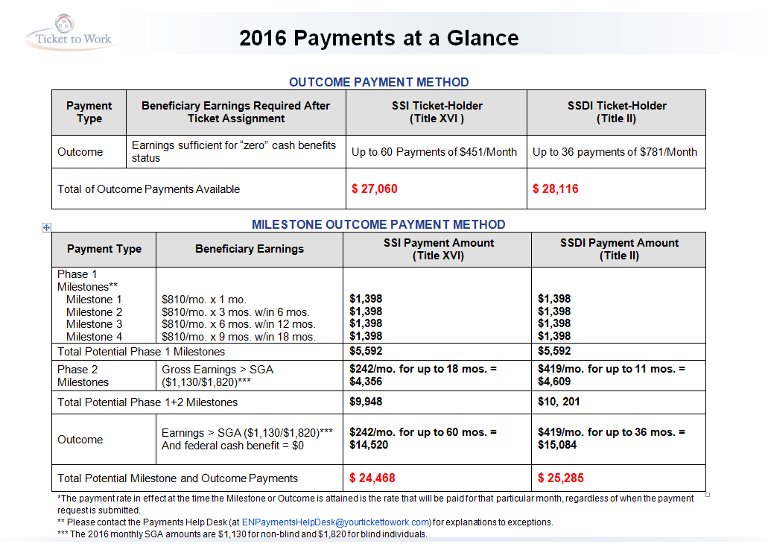

- Most Common Payment Denial Reasons

