Employment Network service providers are required to complete the Annual Performance Outcome Report (APOR) on an annual basis. Below are a few Frequently Asked Questions (FAQ) about the APOR.
Question: How long will I have to complete this report?
Answer: You are required to complete and submit the APOR by February 28, 2017. It will be available for completion on January 26, 2017.
Question: How will this information be used?
Answer: Data provided in the APOR, along with beneficiary satisfaction data, will be incorporated into an EN Report Card, as explained in Part III –Section 9(b) of the Request for Quotation (RFQ).
Question: How often does my EN have to complete this report?
Answer: The APOR is an annual requirement for ENs and is usually forwarded for completion in January of every year.
Question: How do I obtain access to the APOR?
Answer: The Program Contact listed for your Employment Network will receive an emailed link from the TPM via Survey Monkey that will allow access to the APOR survey for completion.
Question: If my Program Contact cannot complete the survey, can the email be forwarded to someone else in my agency who can complete the survey?
Answer: Yes, the Program Contact can forward the emailed link, however it is important to remember that only one submission will be accepted from each Employment Network. The first submission will be counted as the response for your EN.
If your EN submits the survey in error, please send an email to SSAENAPOR@yourtickettowork.com. TPM will delete your ENs response and generate a new survey link.
Question: What if I do not know my business model?
Answer: Service providers that are not sure which business model they operate under as EN may refer back to their Blanket Purchase Agreement (BPA).
If your BPA does not reflect your current business model you must submit a BPA Change Form to ENSB at ENService@ssa.gov.
Question: If I have questions, whom do I contact?
Answer: If you have questions regarding the APOR, you may contact the TPM at SSAENAPOR@yourtickettowork.com.
Question: Why is completion of the APOR required?
Answer: As per the RFQ; Part III; Section 10(b), an EN shall provide to the TPM on no less than an annual basis, in a format prescribed by the Social Security Administration, an APOR. The APOR is to provide information on outcomes ENs achieve with respect to services the EN offers to beneficiaries. Failure to submit a timely APOR could result in contract termination.
Question: By mental impairments, does this mean developmental/cognitive/brain function impairments, or does this refer to mental illness, or both?
Answer: Mental impairments includes cognitive impairments, developmental impairments, brain function impairments and mental illness.
Question: What is the “SSA Security Awareness Contractor Personnel Security Certification” Annual Security Awareness Training?
Answer: This is Form SSA-222, more commonly referred to as the SSA Security Awareness Contractor Personnel Security Certification is the certification referenced in the Agency Specific clause Federal Information Security Management Act (FISMA) and Agency Privacy Management. Please refer to the language in Part IV--Section 3.I of your EN BPA regarding the completion and retention of this document.
Question: What is the timeline for the APOR report? Is it only for the period of January 2016 through December 2016? Or is it further back?
Answer: Responses to the APOR should pertain to January 1, 2016, through December 31, 2016.
Question: I am looking at the SAM.gov site for the end date of my organization’s registration and cannot find it. Where do we find this information in SAM.gov.
Answer: To find your SAM expiration date, go to https://www.sam.gov/portal/public/SAM/##11.Click on the search tab, enter your DUNS and your SAM account information should be provided.
Question: How do you define “benefits advisor?”
Answer: SSA considers a benefits advisor as either a certified Area Work Incentives Coordinator (AWIC) or Community Work Incentives Coordinator (CWIC).
Question: How do you define "Start of Services?
Answer: The Start of Services refers to the date of ticket assignment.
Question: How do you calculate the average number of months between the start of services and the Ticket Holder obtaining employment (question 23)?
Answer: To calculate this average, you need to have two pieces of information for each of your Ticket Holders that are employed: the date the Ticket was Assigned to your EN, and the date that the person began employment. Find the difference between those two dates. Once you have the difference between each date for each employed Ticket Holder, you will need to sum the difference for each person. Finally, divide this sum by the number of people that are employed. Please note that you divide by the number of Ticket Holders that are employed and not by the number of Ticket holders that are assigned to your agency as the average is only for people that are employed. Also note that the question asks for the average number of months. After you are done calculating the number of days between the Assignment date and the Employment start date, and you average the differences, divide the final number by 30 to convert from days into months.
You can accomplish this task in a spreadsheet. Line up the beneficiaries who are employed in one column, copy their corresponding Assignment dates in the next column, and the date that employment began in the third column. In the fourth column subtract the second date from the first by typing an equal sign, selecting the cell of the first beneficiary’s Assignment date, typing a minus sign, selecting the cell of the first beneficiary’s Employment Date and then hitting Enter. You can drag the formula down the column to the end of the list of beneficiaries, by clicking on the little black box on the right hand corner and dragging it to the end of the list. This will give you the number of days between each date. Sum the numbers in the fourth column, and then divide by the number of beneficiaries that are employed. Finally, convert this number to months by dividing by 30.
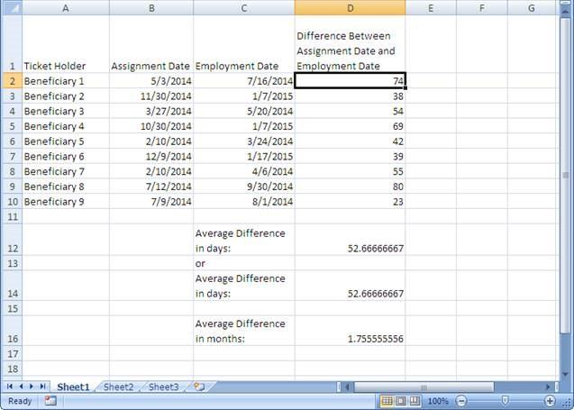
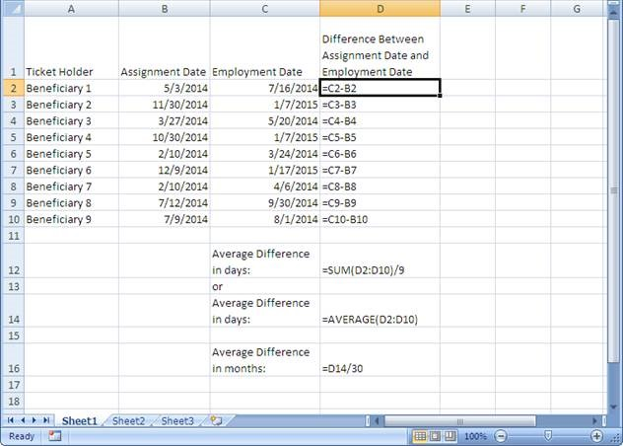
In the first screen shot below you will see the formulas, and in the second you will see the calculated average difference between Assignment Date and Employment Date in months.
Question: How do you calculate the average gross wage per month of the Ticket Holders that you have working if known?
Answer: To calculate this average, you will need to know the gross wages (earnings before any deductions) of each working beneficiary and the number of months that gross wage represents. You will need to sum all of the gross wages for all working beneficiaries, and divide by the number of months this represents. For example, if the sum of gross wages for all working beneficiaries assigned to your EN is $82,800 and this is based on 36 claim months, you would divide $82,800 by 36, which would give you an average gross wage per month of $2,300. Please do not calculate the average gross wage per month for each individual and then average the averages.
Question: Our agency was just approved as an EN and we have not gotten started with any services to clients yet. Do we still need to complete the APOR?
Answer: Only ENs that were Active or On Hold as of January 1, 2016 will need to complete the APOR. If you are still unsure if you need to complete the APOR contact the Ticket Program Manager at SSAENAPOR@yourtickettowork.com.
Question: Does “currently employed full-time” mean now or as of December 31, 2016?
Answer: As of December 31, 2016.
Question: We are a state agency or American Job Center operating as an Employment Network, do we have to complete and submit the APOR?
Answer: No, State Vocational Rehabilitation agencies and American Job Centers do not have to complete the APOR.
Question: How will I know that you received responses?
Answer: You will receive an email confirmation from SSAENAPOR@yourtickettowork.com within 24 hours of your submission, unless you submit it on a Friday afternoon after normal business hours. You will then receive your confirmation on the following Monday.
Question: We submitted our responses but we now want to change some answers. Can we do it again?
Answer: No only the first submission will be recorded. Please ensure you review the questions and prepare your responses prior to entering Survey Monkey to record your responses.

