Agenda

- Introduction
- Employment Network (EN) payment rules and application
  - Phase 1 / Phase 2 Milestones – Part II
    - Earnings
    - 18 - Month Lookback Rule
    - State Vocational Rehabilitation (VR) agency involvement
    - EN Certification of Services (COS)
- Questions and Answers
Aaron Aybar hosted the July 2013 call and introduced the following presenters for the call:
- Debbra Tennessee, Ticket Operations Manager, Operations Support Manager (OSM)
- Dr. Cara Caplan, Deputy Director, Social Security Office of Ticket Operations and Provider Support Services
- Aaron Aybar, EN Payments Help Desk Supervisor, OSM
- Charles Powell, EN Payments Help Desk Technical Assistant, OSM

The July All EN Payments Call was Part 2 of a 3-part series featured during the June, July, and August 2013 All Calls. OSM devotes these calls to the presentation and analysis of case studies that demonstrate how the OSM EN Payments Department staff applies the Ticket to Work regulations, as well as the operational guidelines provided by the Office of Ticket Operations and Provider Support Services (OTOPS) at the Social Security Administration’s Office of Employment Support Programs (OESP).

EN Payment Rules and Application (Aaron Aybar)
Phase 1 / Phase 2 Milestones - Earnings.
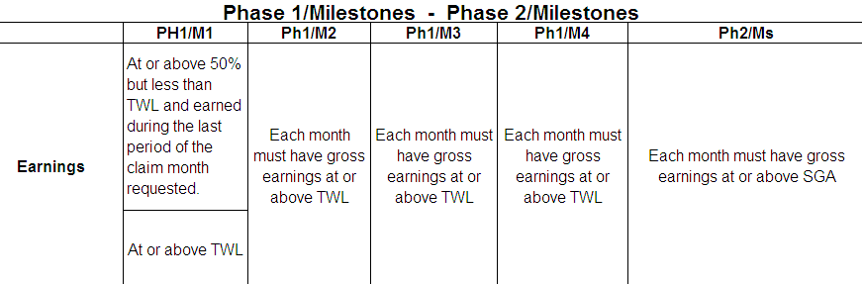
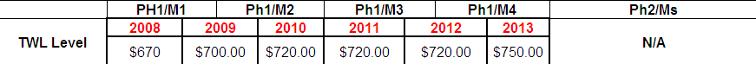
- Rule: For Beneficiaries receiving Social Security Disability Insurance (SSDI) (T2) benefits, the amount of earnings must be earned within the month, the pay period ending date is used to determine Trial Work Level (TWL) (Ph1/Ms) or Substantial Gainful Activity (SGA) (Ph2/Ms) amount. For beneficiaries receiving Supplemental Security Income (SSI) (T16) benefits, the amount of earnings must be paid in the month, the pay date is used to determine TWL (Ph1/Ms) or SGA (Ph2/Ms) amount. For concurrent beneficiaries, the earnings need to coincide with the record (SSDI/SSI) being used. If the SSDI record meets the criteria for payment, earnings will be based on the amount earned in the month. If the SSI record meets the criteria for the payment, earnings will be based on the amount paid in the month. If both (SSDI/SSI) records meet the criteria for payment, the decision of which earnings to use will be based on whichever earnings meet the criteria of being at or above TWL/SGA. If the beneficiary is receiving some type of monthly pension or benefits from other entities, these will not be considered as earnings (example: military pension, state benefits, unemployment).

Phase 1 / Phase 2 Milestones – 18-Month Lookback Rule
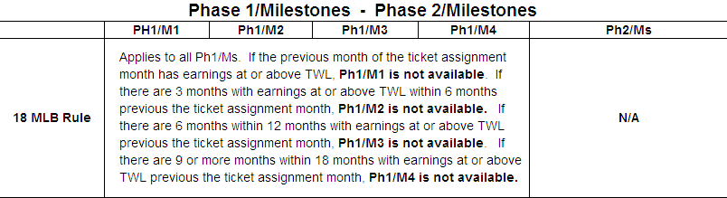
- Rule: Due to updates on benefits status, earnings verified in the Social Security’s database, the availability of Ph1/Ms may change. For example, Social Security may receive notification of earnings at TWL or SGA for months prior to ticket assignment date after Phase 1 Milestone payments have been issued, if this occurs, overpayments would be assessed.

Phase 1 / Phase 2 Milestones – State VR agency involvement
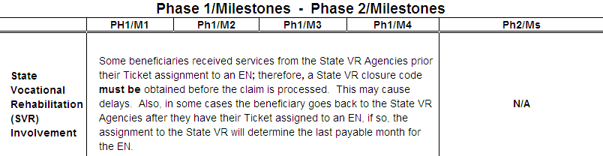
- Rule: If the Ticket was assigned to a State VR agency then assigned to an EN and the State VR agency closure code is successful (i.e. beneficiary working at the time of closure), no Phase 1 Milestones are available to the EN. If the Ticket is assigned to a State VR agency after the assignment to an EN, then, the last payable month for the EN will be the month prior to assignment to the State VR agency. If the current EN is a State VR agency acting as EN and is the same State VR agency that has received a Cost Reimbursement payment, no Ticket to Work payments are available for the State VR agency acting as EN. If Cost Reimbursement payment was not issued and if the SVR closure code was successful only Phase 1 Milestones are unavailable for the State VR acting as EN.

Phase 1 / Phase 2 Milestones – EN COS
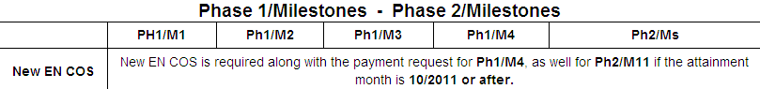
- Rule: The EN COS may be submitted along with the payment request, with the attainment month annotated, or separate from the payment request if the EN provides dates of services for ongoing support after the last EN COS was submitted.

QUESTIONS and ANSWERS

Concurrent Entitlements
If a beneficiary is concurrent for SSDI and SSI, don’t you have to use the SSDI to process a payment? Not SSI?
No. We use the earnings of the program that would meet the earnings qualification for the type of payment. OSM can use either program. The only time we would not is if there is a change in beneficiary’s entitlement to a particular program.

18-Month Lookback Rule
Can someone give the reasoning why an EN cannot get paid if the beneficiary has had some earnings above TWL prior to assigning the Ticket?
Phase 1 Milestone payments are issued to ENs who assist beneficiaries to get back to work and achieve earnings at TWL. If beneficiaries have already achieved this goal, then the Phase 1 milestone payments are excluded.

VR Closures
Please clarify if the successful Vocational Rehabilitation closure rule applies if the Vocational Rehabilitation closure was prior to the changes in 2008?
Yes. The rule applies if the Vocational Rehabilitation closure was prior to 2008. Vocational rehabilitation closures apply to cases closed 2002 and later.

