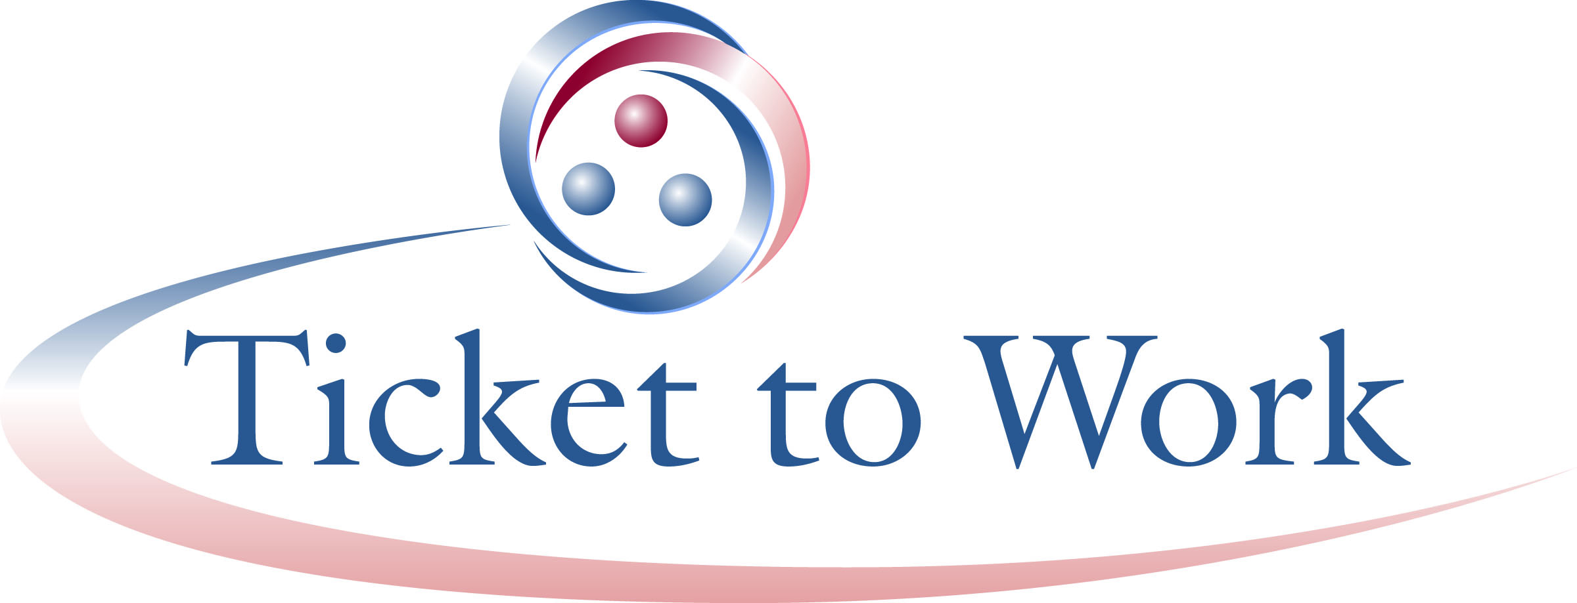

Vocational Rehabilitation (VR) Monthly Recap

March 10, All VR Call Recap
Email: svrhelpdesk@yourtickettowork.com

SSA Updates
Cost reimbursement claims status: The Social Security Administration (SSA) paid out over $51 million in cost reimbursement claims to date in the fiscal year, which is nearly $11 million ahead of last year this time. SSA is still working on a few October claims. If State VR agencies have outstanding claims from September 2014 or earlier, please send an inquiry email to the VR help desk (VR.helpdesk@ssa.gov) or fax an inquiry on the claim(s) to 410-966-3280. Include an email contact for faxed inquiries. SSA will follow up. SSA encourages VR agencies to stay abreast of cost reimbursement claim submissions.

QBER and the Ticket Portal: State VR agencies were reminded to review two GovDelivery messages from Associate Commissioner David Weaver dated Friday, March 6 and Tuesday, March 10. The March 6 message (http://content.govdelivery.com/bulletins/gd/USSSA-f608c8?wgt_ref=USSSA_WIDGET_4) provided information on the unavailability of the QBER data effective March 12, and the expansion of ePay to all Employment Networks. VRENs will continue to get electronic milestone and outcome payments. In lieu of QBER data, SSA will notify State VR agencies of those individuals who may potentially qualify the agency for cost reimbursement based on earnings in our records. VR agencies can file cost reimbursement claims based on the SSA notification list. The second message, dated March 10, contains information on the new Ticket Portal, including a link to Ticket portal resources (http://content.govdelivery.com/bulletins/gd/USSSA-f6da7e?wgt_ref=USSSA_WIDGET_4).

In-Use electronic files: When transitioning to the Ticket Portal, VR agencies will not need to make any changes to the files sent to SSA for In-Use assignments. In addition, the files sent back from SSA will not be changed. No VR programming changes will be required to receive the current level of information. A new option for obtaining additional explanatory information on why an assignment did not go through will be available from SSA. State VR agencies interested in receiving this additional information with their return file will need to make a programming change. However, it is optional as to whether a VR agency receives this new detail and makes the required programming changes. SSA will provide a complete guide regarding the submission of VR files using the new portal in the future, prior to transition from the current to new process.

Ticket Portal Demonstration
A simulated navigation through the main menu and submenus of the Portal was provided. Screenshots of various Ticket Portal pages accompanied explanations of the actions that can be taken by State VR agencies to enter, update or retrieve information. The transcript and audio from the presentation are available at: https://yourtickettowork.com/web/ttw/events-archive.

The functions of the current and new portals were compared. There are different access requirements for the new portal. Access requirements include Suitability clearance and a valid password and user name. Individuals at State VR agencies can create both by establishing a “My Social Security account” with “extra security” at: http://www.ssa.gov/myaccount/. There is an 800-number on that site if you have problems creating a password or user name.

Ticket assignability, including assignments and unassignments, can currently be done by batch or one-at-a-time, with a 2-3 day delay to update assignment files. The Ticket Portal also allows for Ticket assignment batches or one-at-a-time assignments, but the Ticket assignment status is real time with no delay. Changes can be viewed as they are made and are effective immediately.

Payment requests available through the new portal are for Ticket milestone/outcome payments. SSA anticipates that by the spring of 2016 a VR cost reimbursement payment request feature will also be available.

We will be providing more information about current versus new portal functions later.

The new portal is part of a larger effort to modernize and consolidate SSA’s Return to Work programs. SSA was able to connect and synchronize data in the portal system from various sources. This reduces loss of information and delays caused by current manual processes and provides secure and up-to-date information. These improvements will translate to administrative efficiencies for ENs and improved customer service. All Portal users will be able to access the most current information, in most instances real time information.

The next All VR Call will be held on Tuesday, April 14.

To view full transcripts, presentation materials and listen to the archived audio presentation for any of the OSM’s national calls, visit the Events Archive at https://yourtickettowork.com/web/ttw/events-archive.

