**Agenda**

* Announcements
* EN Payments Timeline
* Overpayments (Incorrect Payments)
* Processing Available Payments
* Expedited Reinstatement of Benefits (EXR) Cases
  + What is EXR
  + How EXR may affect Ticket Payments
* Terminated Tickets
* How to navigate in the portal to determine ticket status
* The Bond Program
* Then our Questions and Answers Forum

**Announcements:**

**Virtual Job Fair**

Our next Virtual Job Fair is scheduled for Wednesday August 24, 2016 (between 11am – 5pm).

The Virtual job fair will connect Social Security disability beneficiaries to companies that do business with the government.

**By participating in the fair, beneficiaries can**:

* Talk with job recruiters online via chat forums and one-on-one messages.
* Visit virtual resource booths to ask questions about job accommodations, Social Security Work Incentives

**To participate in the virtual job fair, you must:**

Be between the ages of 18 and 64;

Receive Social Security disability benefits;

Your Ticket must be in use to receive services from an approved Employment Network (EN) or Vocational Rehabilitation (VR) agency

* + **EPAY Update**

We expect to begin processing the next EPAY File towards the end of July.

**Reminders**

* If you have evidence of earnings, you may submit your payment request through the Ticket Portal instead of waiting for the E-PAY process to run.
* Ensure that your EN payment contact information is current. We reference it for payment outreach messages and confirmation of possible Split Payments.
* When submitting information to ENSB about payments, please annotate your EN Contact Information for Payments. To add a payment contact, send a request to [enservice@ssa.gov](mailto:enservice@ssa.gov) and specify the name of the person with the title you want them to have. All payments contacts must have completed suitability.

**EN Payments Timeline**

All EN payment claims are adjudicated per our contractual obligations within 30 days of receipt.

Definition of processed:

Paid - All required information is provided and a payment has been issued via the U.S. Treasury.

Denied - Information submitted with the Payment Request is not sufficient to support a payment from Social Security. This could include low earnings, earnings that are not substantiated for the appropriate number of months and also the EN’s lack of follow up with the Ticket Holder.

Diary - Required information has not been provided and we have asked the EN to provide that information. Case will remain open for an additional nine business days. If the missing information is not provided within that time, the case will be finally adjudicated as a denial.

**EN Payments Timeline (Cont.)- Pie Chart**



Total Claims Processed June 2016: 14,943

**June 2016 EN Payments Metrics**

100% of claims received were processed within 30 days (14,943 claims)

**June 2016 EN Payments Metrics**

Total Number payments made 12,396 which Represents 83% of claims processed

Total Number of Denials made 2,387 which Represents 16% of claims processed

Total Number of Diaries were 160 which Represents 1% of claims processed

June 2016 – Total Payment amount $8.6 million

**EN Payments Timeline (Cont.)**

If you receive an EN payment Outreach e-mail from the EN Payments Help Desk indicating that there is some information missing from your Payment Request, please submit the information as soon as possible to avoid having your Request denied for lack of response. The EN Payments department will only hold a Payment Request for nine business days while waiting for a response to an Outreach e-mail.

EN’s should review the Ticket Portal to find out the status of their Payment Requests. If there is no change in the status of a Payment Request for over 30 days please contact the EN Payments Help Desk so we can research the situation.

**Overpayments (Incorrect Payments)**

Incorrect Payments occur when information becomes available to Social Security that a payment made previously to an EN was not valid.

A payment to an EN can be invalidated by the discovery of qualifying earnings information or successful State VR agency case closure status.

Once Social Security staffs determines that an Incorrect Payment exists they will send an email to the EN. The communication will state the reason for the Incorrect Payment and the options available to the EN   
to repay that money.

The reimbursement options are:

* Immediate payment by check,
* Make a payment arrangement, or
* Have future payments withheld until the balance is covered.

**Overpayments (Incorrect Payments) (Continued)**

* If Social Security does not receive a response from the EN to the incorrect payment notice they will withhold any future payments to the EN until the incorrect payment has been recouped.
* Social Security does not have to recoup payments specifically from the SSN that was improperly paid. Social Security can recoup money from any EN payment for any beneficiary assigned to the EN until the incorrect payment has been cleared.
* Recoupment of Incorrect payments are handled by Social Security
* The EN must respond to Social Security’s Incorrect payment notice, but if you reach out to the EN Payments Help Desk, please forward the communication that you received from Social Security to expedite a response.

**Processing Available Payments**

EN Payment staff are instructed to review all systems and beneficiary records when processing a claim.

Once staff analyzes all records, Payment Staff will create a work case.

A payment determination will be made regarding previous payments made and available payments based on evidence of earnings submitted on behalf of the EN or information contained in Social Security’s systems.

If the payment request submitted meets the criteria for payment, the payment request is then processed for payment. If additional payments can be made outside of what the EN requested, the Payments Staff member will process ALL payments that meet criteria, even if ENs do not request the additional payments.

**Processing Available Payments (Continued)**

There are occasions ENs may not request Phase 1 milestone payments; however, the TPM may deny some or all Phase 1 milestone payments and pay either Phase 2 or outcome payments.

TPM will deny all Phase 1 milestones that are excluded due to Lookback earnings and VR successful closures. These exclusions are considered “unavailable” payments.

Social Security systems annotates a specific code to all Phase 1 milestone exclusions.

The system will automatically “exclude” these monies with the specific code annotated from any reconciliation payments and eliminates possible incorrect payment of unavailable payments.

**Expedited Reinstatement of Benefits (EXR)**

**What is EXR?**

* The Expedited Reinstatement of Benefits (EXR) provisions in the Ticket to Work provides both Supplemental Security Income (SSI) and Social Security Disability Insurance (SSDI) beneficiaries with a level of economic security. An individual who is requesting EXR is often in a financial dilemma and or experiencing declining health or medical condition.
* A Ticket Holder is a candidate for EXR because he or she has either stopped working or has experienced a significant loss in monthly wages that puts his/her earnings below the Substantial Gainful Activity (SGA) level

**Expedited Reinstatement of Benefits (EXR)(Continued)**

**How EXR May Affect Ticket Payments:**

* Beneficiaries may receive provisional payments for a 6-month period while their EXR claim is being reviewed. Once provisional benefits begin, payments to the EN will stop. Once an outcome payment is received payments cannot go back to Milestones.
* If Social Security approves the EXR claim, the beneficiary’s ticket will be terminated and has no more value (EN is not due any additional payments).
* Social Security will issue the beneficiary a new ticket with its own value. (For 2016 the full value of a ticket: SSDI - $25,285, SSI - $24,468)
* The beneficiary must assign his/her new ticket to an EN. The previous EN is not entitled to any payments on the new ticket unless the beneficiary assigns his/her new ticket to the same EN.
* ENs who are in contact with beneficiaries should know if beneficiaries have submitted EXR claims and the disposition.

**Terminated Tickets**

**Terminated Ticket:** Tickets can be terminated for a number of reasons.

* Change in the person’s benefit status
* Benefit cessation or termination based on a medical Continuing Disability Review – Normally performed after a failed Timely Progress Review (TPR)
* The maximum number of payments on that Ticket being paid out.
* Beneficiary reached full retirement age
* Beneficiary is deceased.
* Social Security approved an EXR claim.
* EN is no longer eligible for payment after it has been terminated. In most cases the last payable claim month for terminated Tickets is the month prior to the date of the Ticket termination.

**Terminated Tickets (Continued)**

* ENs can determine the reason for some terminated tickets
* Check the Ticket Portal for the number of outcome payments paid on a Ticket. If maximum number of outcome payments are made, the ticket will be terminated.
* ENs in contact with beneficiaries. Beneficiary will inform ENs of approved EXR claims since the beneficiary needs will change and different services may be required. It beneficiary has an approved EXR claim, the ticket has been terminated and a new IWP is required if the same EN provides services.
* Medical CDRs performed for beneficiaries with a failed TPR. ENs are informed of TPR status.
* If you believe a ticket was erroneously terminated, you can contact the Payments Help Desk by email at [enpaymentshelpdesk@yourtickettowork.com](mailto:enpaymentshelpdesk@yourtickettowork.com) or by telephone at 1-866-949-3687 to determine if the termination was valid

**Individual Ticket Status and Use History**

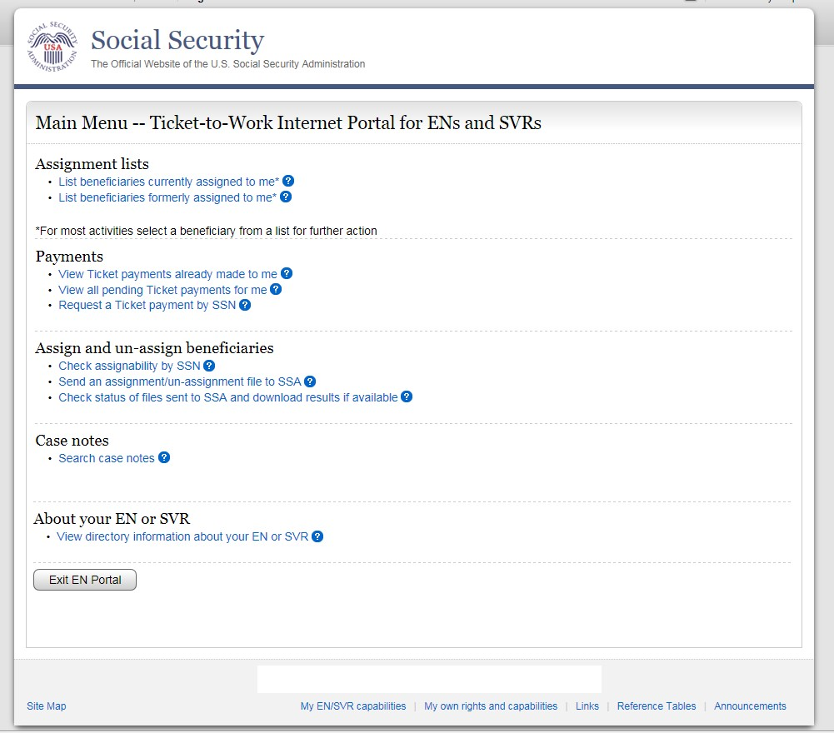

From the Main Menu select the ‘Check assignability by SSN’ link. The ‘Individual Ticket Status and Use History’ screen will display. This is an interactive screen. You must enter a SSN to review the Ticket Status and Ticket Use History.

**Individual Ticket Status and Use History (Continued)**

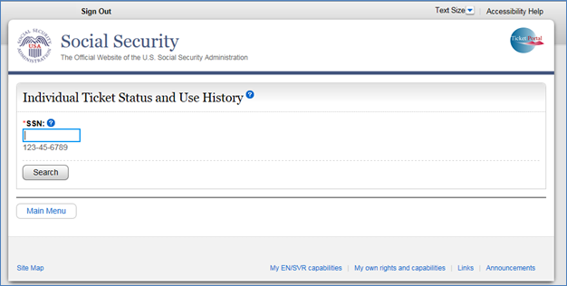

You will then be prompted to enter the associated Social Security Number and select search.

This page allows you to check the assignability of a single Social Security Number (SSN). You must enter a SSN and hit search to review the Ticket status and use history. This screen is also the first step for assigning new tickets. The next screen will display ticket information based on that SSN.

**Individual Ticket Status and Use History (Continued)**

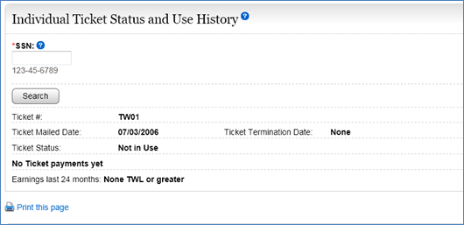

The screen will display the information for the Ticket Status and Ticket Use History based on that SSN.

In the screen shot provided you will be able to view the Ticket Number, Ticket Mailed Date, Ticket Status, **Ticket Termination Date**, No Ticket Payments Yet and Earnings within the last 24 months.

In this particular example provided the ticket status is not terminated. But if it were the Ticket Termination Date information would be listed

The Bond Program

The Benefit Offset National Demonstration

During this portion of the presentation we will provide an overview of The Bond Program.

**The Bond Program**

The Benefit Offset National Demonstration (BOND) is a demonstration program was created in 2010 to help (SSDI) beneficiaries return to work. Full project implementation began in April 2011 with enrollment of beneficiaries ending in September 2012. The BOND project will continue to operate for enrolled participants through September 2017.

The participants in the program were randomly assigned to:

* A group that is notified that they are eligible for a benefits offset if they return to work,

**The Bond Program (Continued)**

* The BOND program is designed to test a different way of treating SSDI beneficiaries' work and earnings, through the use of a benefit offset similar to the $2 for $1 offset that Social Security uses in determining the monthly benefit amount for Supplemental Security Income (SSI) recipients.
* Under the current rules, SSDI beneficiaries face an income cliff when their work and earnings result in the cessation of their monthly benefit checks. Prior to hitting this income cliff, a SSDI beneficiary will receive his or her full benefit amount as well as his or her earnings from work. When the beneficiary’s work and earnings are high enough to result in benefit cessation, the full monthly benefit amount suddenly stops.
* The benefit offset in the BOND program is intended to help SSDI beneficiaries’ transition gradually off benefits. The program is now being tested in ten sites covering roughly 20 percent of the country. Beneficiaries who are chosen for this demonstration must remain in the program regardless of where they live and which EN is serving them. It is possible that one or more BOND participants or BOND beneficiaries are already part of your EN’s client base or will be in the future.

**The Bond Program (Continued)**

**Transition from Bond Participant to Bond Beneficiary:**

* The BOND participant will become a BOND beneficiary when he or she has completed a work continuing Disability Review (CDR), is earning at the applicable SGA levels and the offset has begun. The work CDR is best described as a review of a beneficiary’s work and wages to determine whether he or she is still eligible for benefits.
* Social Security policy states that certain “events ... may prompt a work CDR." Those events include the completion of a Trial Work Period or the receipt of work reports from any number of places, including: a voluntary report from the beneficiary; a report from a State Vocational Rehabilitation (VR) agency, or a report from an (EN) seeking payment~~s~~ under the Ticket program.